SPRING 2026 Fish Order Form- Wells County

Name: Address: Phone #: _______________
Email Address: _
Orders Due with payment
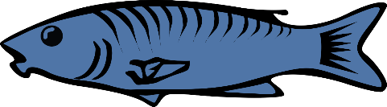
by Thu., April 23rd to SWCD Office.

Name/Type |  | Price Each | Price per 100 | Quantity | Total Amount
Redear Sunfish | 2-3" | $1.05 | $100/100
Lg. Mouth Bass | 2-4" | $1.70 | $165/100
Bluegill | 2-3" | $1.00 | $95/100
Hybrid Bluegill | 2-3" | $1.00 | $95/100
Channel Catfish | 4-6" | $1.00 | $95/100
Black Crappie 3-4” |  | $1.55 | $150/100
Jumbo Bullfrogs Tadpoles |  | $1.05 | $75/100
Fathead Minnows | 1-3 Lbs. | $18.50/lb
(approx. 250/lb) >3 Lbs. |  | $16.50/lb
Triploid Grass Carp |  | $24.00 | $138/6
**MINIMUM ORDER OF 6 DELIVERY CHARGE FOR CARP
We will need exact directions to pond where
grass carp will be delivered.
 |  |  | $40.00
Floating Fish Food 50 lb bag |  |  | $43.00
 |  |  | Sub-Total
 |  |  | 7% Sales Tax
 |  |  | Total

Pick up on April 30th from 10 -12 noon (Not responsible for fish not picked up by noon )
For questions call the Wells SWCD Office at 260-824-1930 ext. 3

